STENCIL 6A.
THE FUTURE CONTINUOUS

EXAMPLES
- Tomorrow at this time, I will be taking my English language exam.
Tomorrow at this time, I am going to be taking my English language exam.

- Ben won't be having visitors next week.
Ben isn’t going to be having visitors next week.

- Will you be coming to the party next month?
Are you going to be coming to the party next month ?

FORMS
will / won’t | be | present participle
will | be | taking
won’t | be | having
will | be | coming

to be (am, are, is) going to | be | present participle
am going to | be | taking
isn’t going to | be | having
are going to | be | coming

GRAPH

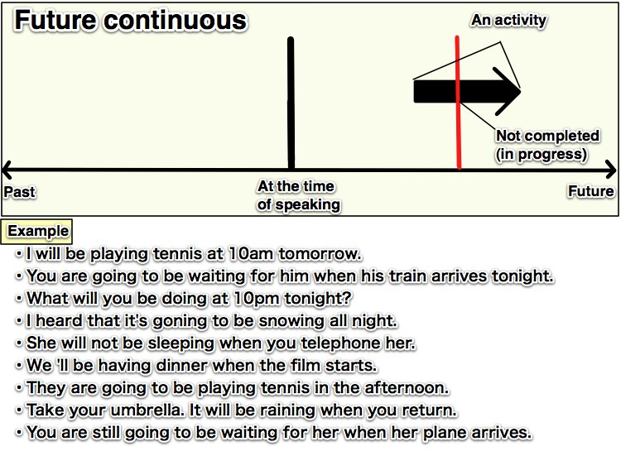
RULE:
We use the future continuous when we want to talk about activities that will be in progress at a certain time in the future.

